CSIS3280-50 Assignment 4 Winter 2017
Due Date: Apr. 13th/2017
You can do this assignment with ONE partner

Your folder structure for the assignment should be similar to:


Where your php /html files are stored.
Pictures are stored

This assignment involves a number of PHP programs, accessing various mySQL databases. The following describes the functionality of the various programs. You can use “cookies” for this assignment BUT NOT sessions.

You are in charge of writing for a Shaw Channel selection web site. The following are the various web scripting programs you need to write for this site.

channelLogin.php

This is the opening program for your site. Note, lastname can have up to 20 chars MAX, BUT the password MUST be 7 chars. in length.

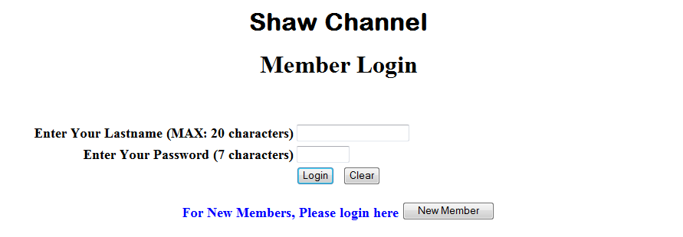

Note that this is a “sticky” form. If the user enters the wrong Lastname/Password combination, then it should

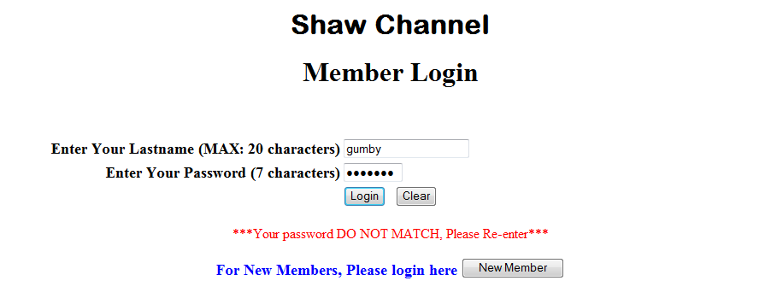

If the user enters the wrong length for lastname and/or password



Finally, If the user did not enter anything in the text boxes and pressed the “submit” button, then:

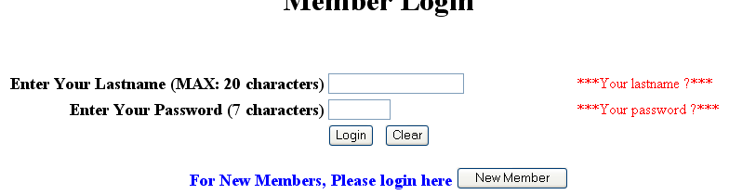

addNewCust.php
If you are a new member, click the “New Member” button, and it should take you to this program, which is also a “sticky” form. The following shows the main screen with some data entered (initially of course all the fields are blank):
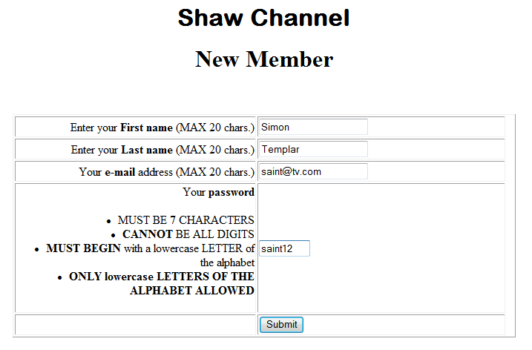

Note the restrictions on the data entries. The following shows the typical error messages if you violate any of the rules.

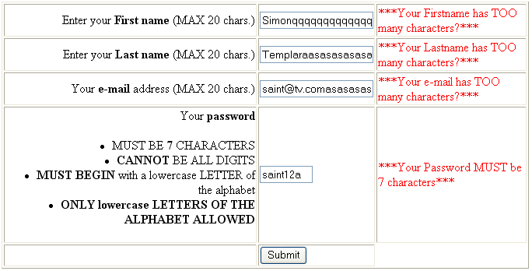

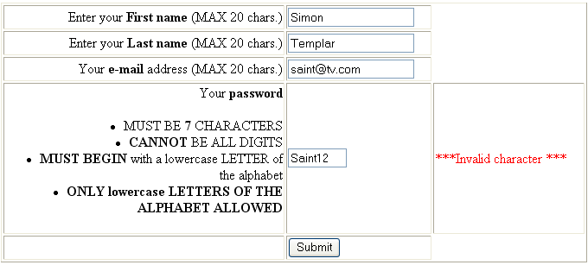

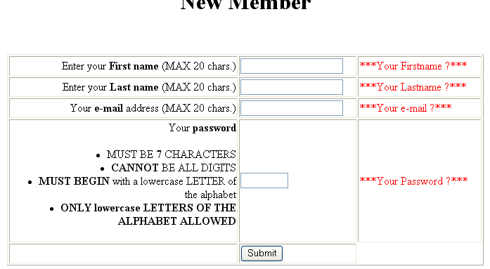

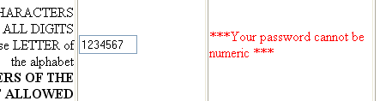

Now, assuming user Simon Templar has been processed and is now a member, if another user later on, tries to become a member, with the same lastname and password combination, then the following should appear:
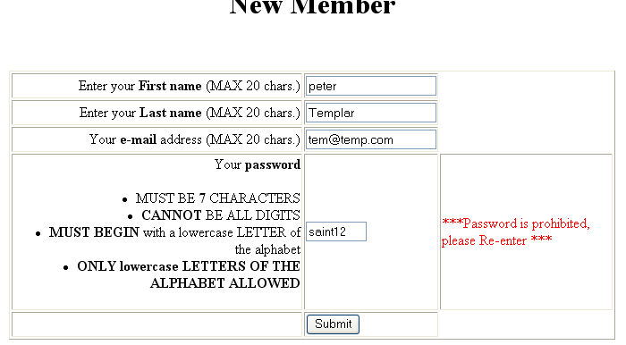

So, although he is a new member, but because of the same lastname/password combination, the password is “prohibited” (the reason is not given, as you may not want anybody to know there is already a person with that lastname/password combo). This user will need to re-enter a new password.

titleSrch.php

If the data is entered correctly, then after “submit” from “addNewCust.php or “login” from “channelLogin.php”, it should go to this program and display the following (here assuming “Simon Templar” has either logged in or straight after “submit” from “addNewCust.php”:

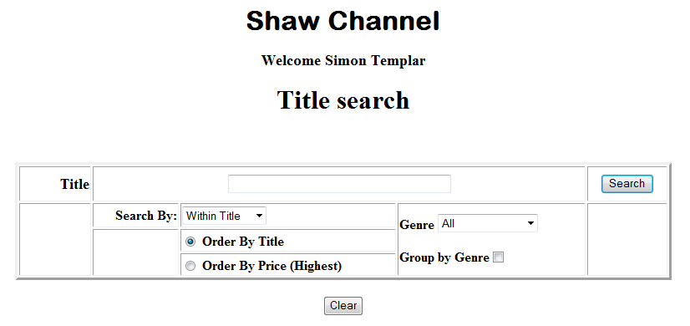

Note. 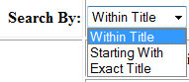 and “Within Title” is the default for the search criteria.
For Genre, it is 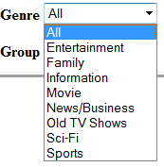, with “All” being the default.

If the user clicks the “search” button, then it should invoke fetchDisplayChannel.php and display all the available channels falling under any genre , i.e.:

From fetchDisplayChannel.php
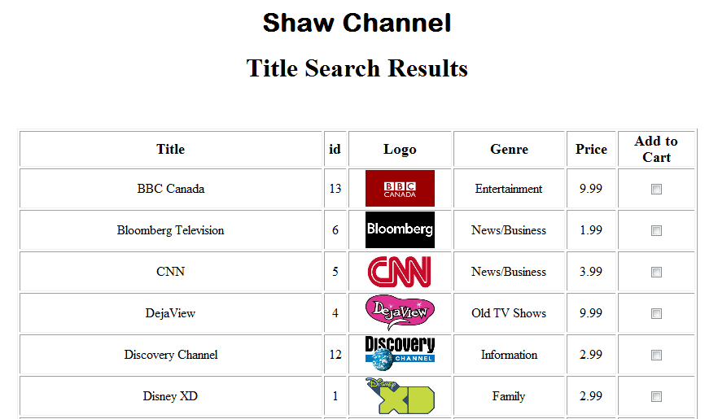

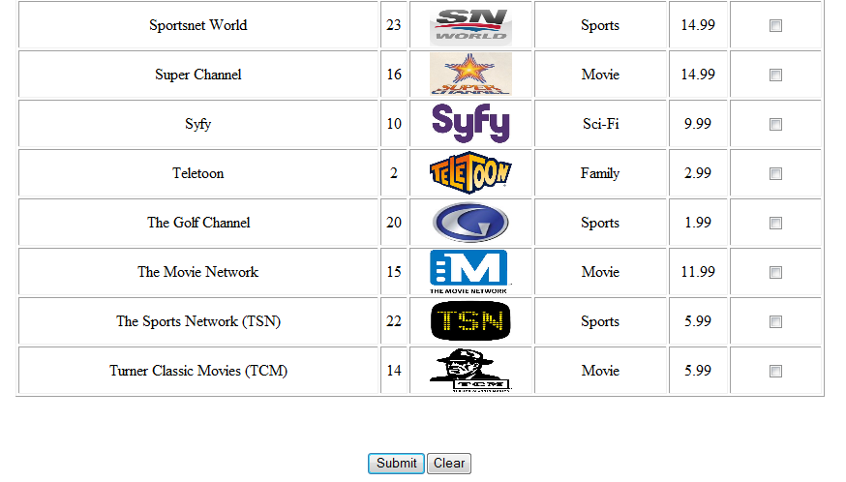

If the user clicks the browser “back” button, it goes back to “titleSrch.php”. Now if the user entered say:
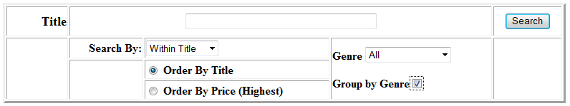

i.e. display channels in all genres in ascending sequence of title but grouped by genre, then “fetchDisplayChannel.php” should display:

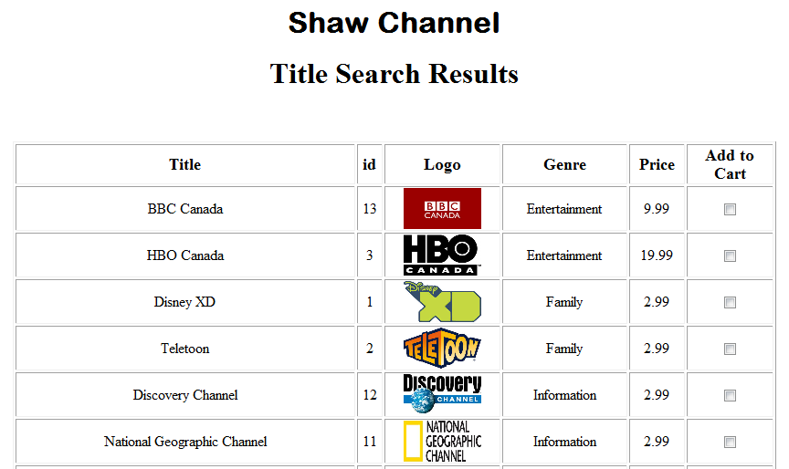
…….
…….
……
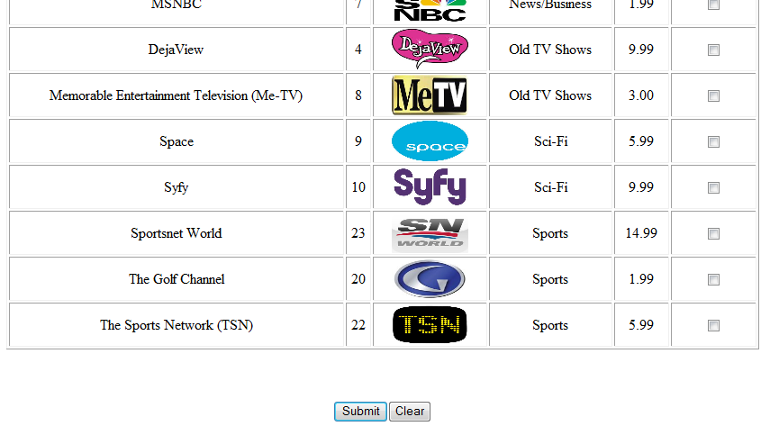

You can see how the results (not all are shown) are grouped by genres, starting with “Entertainment” to “Sports”.

If the user clicks the browser “back” button, the following was used:
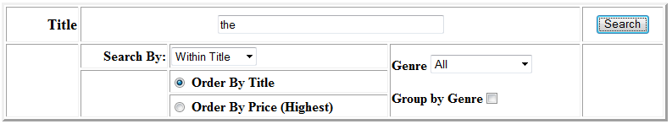
i.e. channels containing “the” anywhere in the title, for all genres, then “fetchDisplayChannel.php” should display:

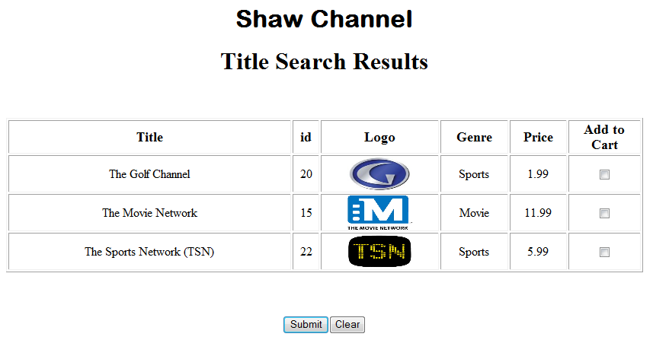

If the user clicks the browser back button and instead chose to search but only within “Sports” genre, i.e.

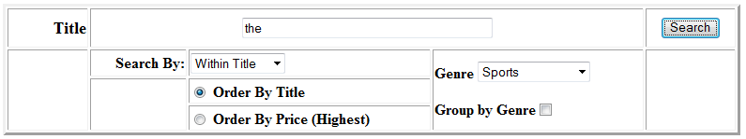

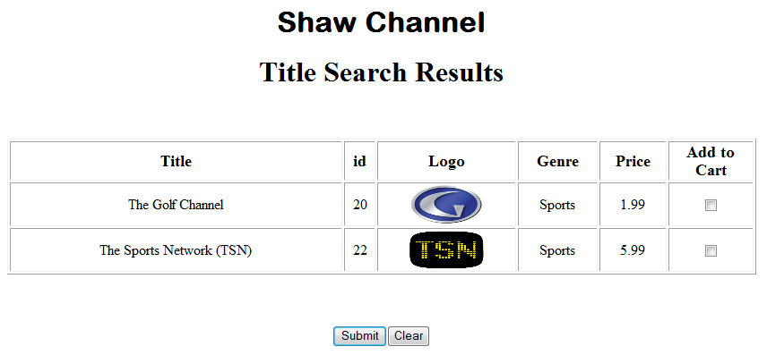

If there are no channel titles fitting your search criteria, then upon clicking the “search” button, it should display:
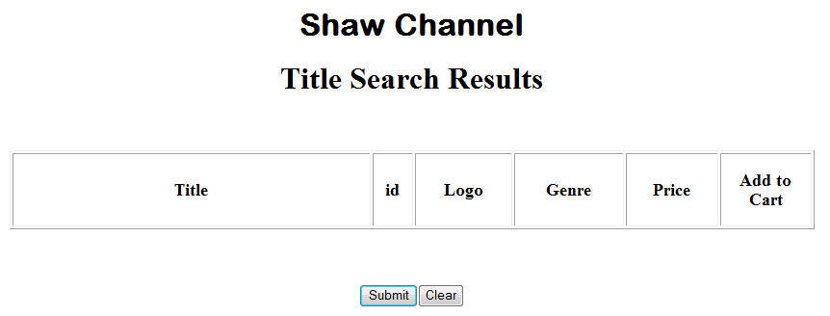

If the user entered:
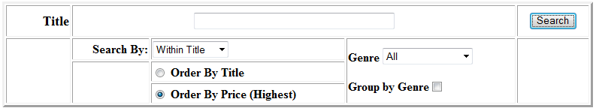
i.e. sort by Price, (and then by ascending title) then the output should be:

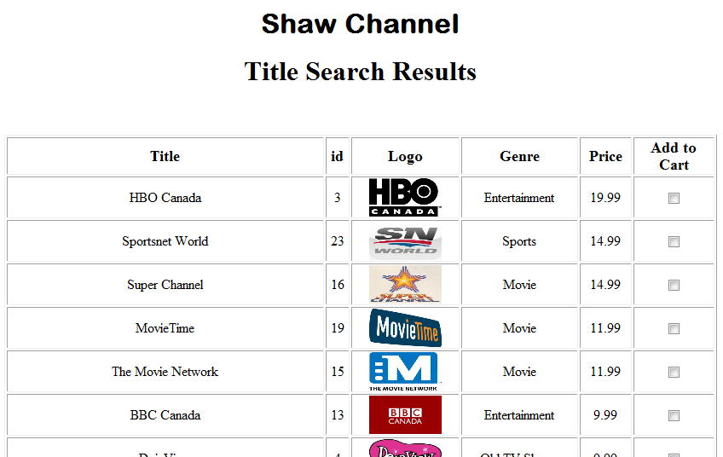
Above shows the partial results.

Assuming the following checkboxes are selected
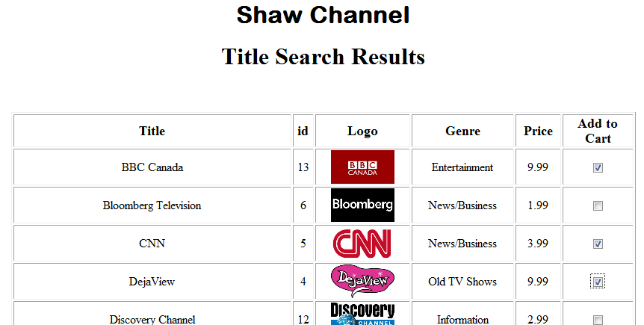

addOrderChannel.php
When the submit button is clicked, this program should display the following (assuming the previous selections)

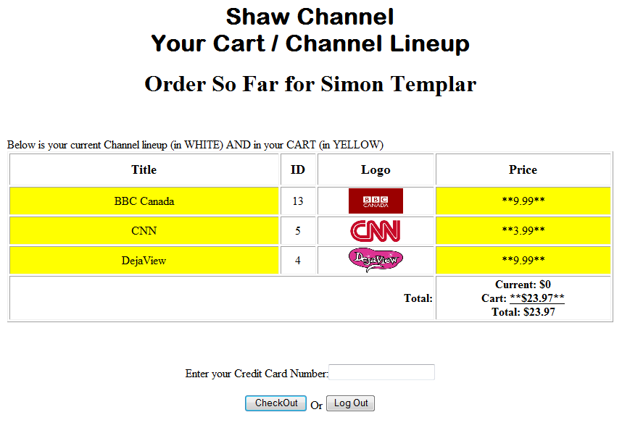

If was clicked on, but no credit card entered, then it should display:

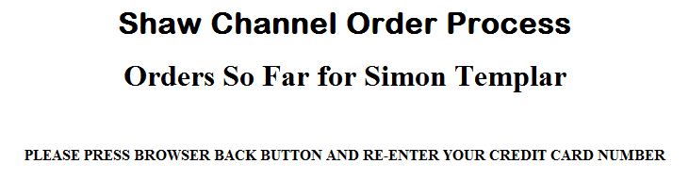

processChannelOrders.php
If a credit card is entered and button clicked, then processChannelOrders.php will process the orders and display:
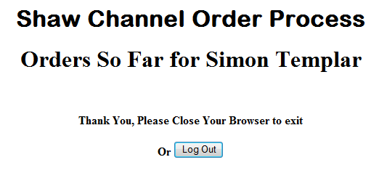

NOW, if the user “presses” the browser’s <back> button, you may see this again:

If this is so, and user re-enters the credit card and clicks, then it should display:
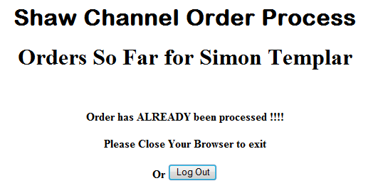

Assuming user “Simon Templar” clicks the browser back button and goes back to the search screen and makes the following selection:

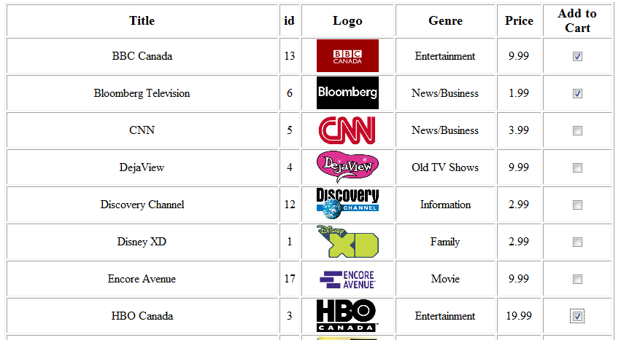

(And yes, the user can select “BBC Canada” again, however as you can see below, it will not be added to the cart again)
And clicks “submit” which would then display:

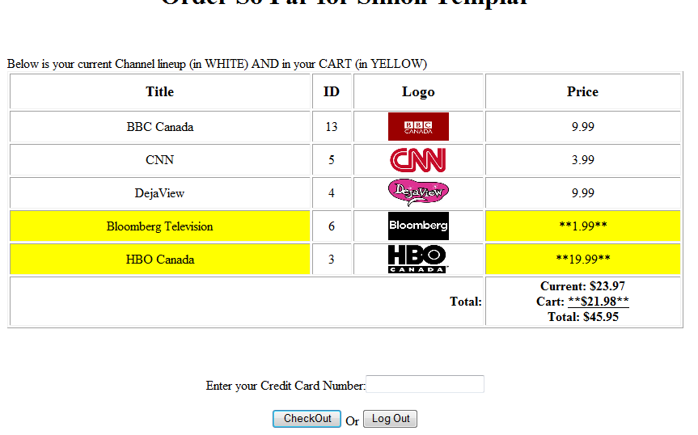

Note, the different totals. The “Current” total calculates the current channel line up (the ones in white), the “Cart” only accumulates the channels in the cart (i.e. the ones in yellow). The user essentially pays for the “Cart” price with the credit card. (The last total will be the user’s new monthly total to be charged monthly to the customer in the following months ahead)

If the user clicks (please see later for exact behavior of this button) without entering the credit card, but logs back in later, and makes his or her way back to the checkout page (without adding more channel titles to the cart), it should display:

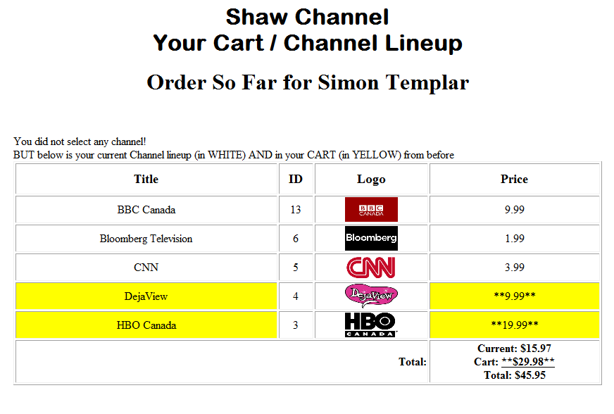


If the user has entered the credit card, checked out and logs back in later but makes no channel selections, then when he or she makes it to the checkout, it should display:

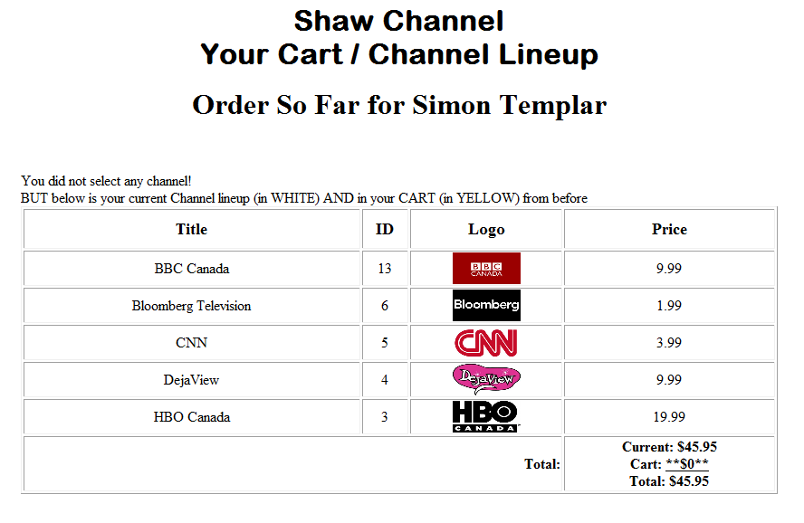

Notice the last line has no credit card text box or checkout button. Also there are no more channel titles in the cart for this customer (i.e. all the channel titles are displayed in white).

The Log Out button
In the previous screens you may have noticed the button. Whenever the user clicks this button, it should take the user back to the “Member Login” screen, i.e.

mySQL databases

The following is the main mySQL database to be used. (You can create these using “phpMyAdmin” or through the mySQL console).

This database will have the following tables and their corresponding fields.
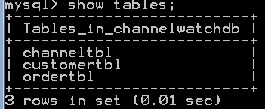

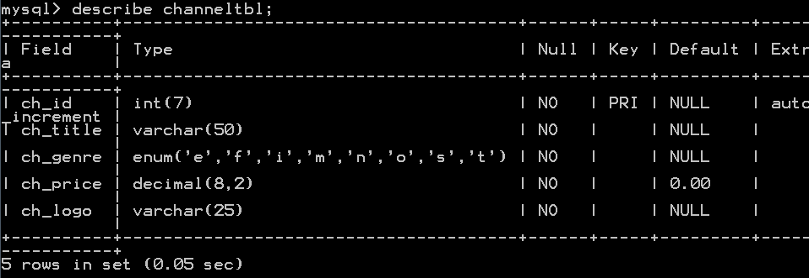
The above table will store the various channel titles.
Note the ch_genre is (‘e’ for Entertainment, ‘f’ for Family, ‘i’ for Information, m for Movie, n for News/Business, ‘o’ for Old TV Shows, ‘s’ for Sci-Fi and ‘t’ for Sports). Make sure to declare the characters in this sequence.

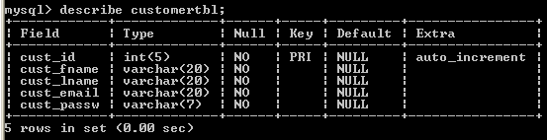
The above table will store the various customer members.

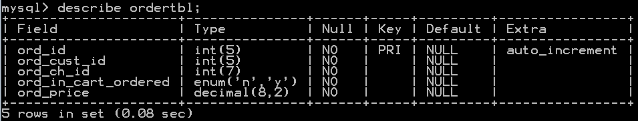
The above table will store the various orders made by the customers.
Note, the “ord_in_cart_ordered” takes 2 values:
‘n’ for not in cart, i.e. that channel is now part of the customer’s channel line up.
‘y’ for in cart, i.e. that channel is in the cart, but not yet part of the customer’s channel line up.

The following are some sample data for each table (you can change/add your own)
channeltbl
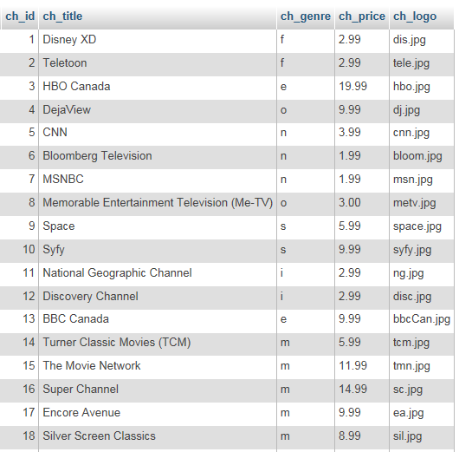
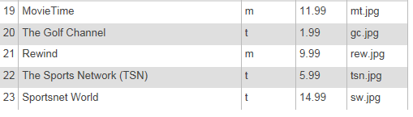

customertbl
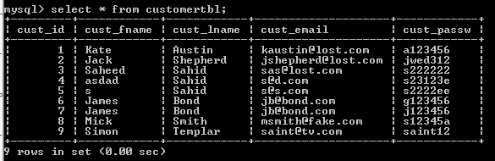

ordertbl
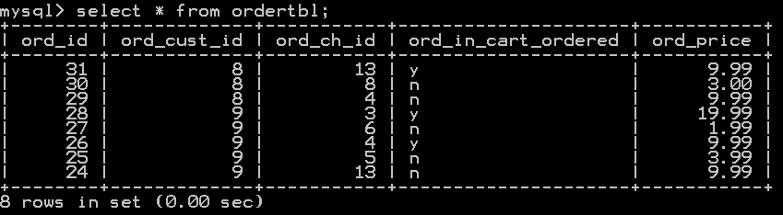

Picture Logos
The picture logos for the various tv channels will be given. Please place the pictures in a separate subfolder called “logos” as indicated on page 1.

Other Programs
Feel free to create other PHP programs as you require it. (You may want to do one for “cookies”)

Saving the Database

When you create the “channelwatchdb” database, the default storage engine for each table may be “InnoDB”. Please convert the storage engine to “MyISAM”,
To do this in phpMyAdmin

- Load up phpMyAdmin
- Click on “channelwatchdb”, i.e.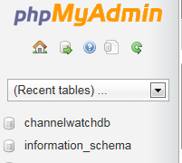
- Click on the first table, “customertbl”, i.e. 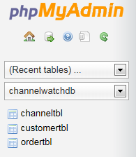

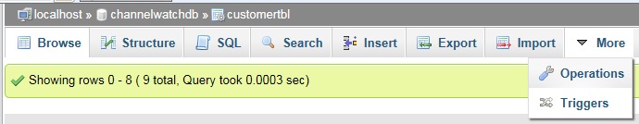

- Select “Operations” from

- Select “MyISAM” from Storage Engine 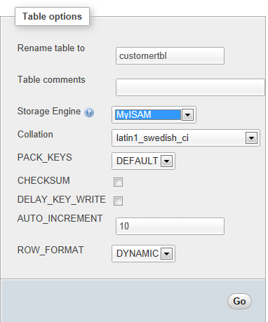

- Click the corresponding “Go” button

- Repeat this for all your channeldb tables.

If you check your “channeldb” folder in wamp, i.e. 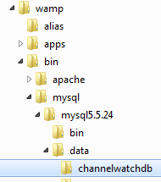, you should have:
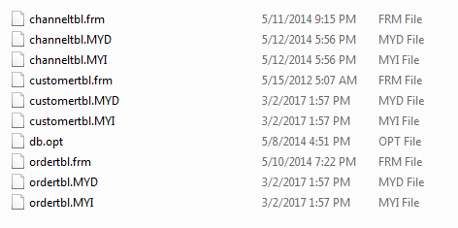
You can now backup your entire database, just by copying that channelwatchdb folder.

What to hand in:
- Front cover page with your name (your partner’s name), course, assignment number, instructor’s name, section and due date. (If you did this assignment with a partner, then hand in ONE piece of work with BOTH your names on it).
- Hardcopy of the program listing.
- Zip up the web page ,php program and mySQL database, and save as csis3280W2017YourNameAs4.zip and do a file submission through myDouglas

Please Note, for the mySQL database, give me the actual database itself from the
“wamp\bin\mysql\...\data\” folder (rather than any mySQL script)

MARKS WILL BE LOST IF ANY OF THE ABOVE IS NOT MET OR IF THIS IS NOT YOUR OWN WORK

